Grandma Taylor’s Quick Cocoa Cake
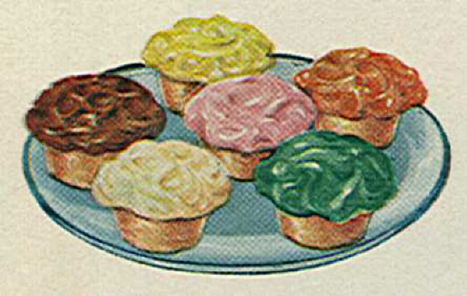

Mix together:
- 2 cups flour
- ¾ cup white sugar
- ¾ cup brown sugar
- 6 tbsp cocoa
- ½ tsp salt
- 1 tsp baking soda
Add:
- 2 eggs
- 1 ½ tsp vanilla
- ¾ cup melted margarine or butter
- 1 cup cold water
Beat well. Bake at 350 degrees
- 20-25 minutes for cupcakes
- 30 minutes for 9 by 12 inch pan

Frosting
- 4 cups powdered sugar
- ¼ lb soft margarine or butter
- 1 tsp vanilla
- Sift in 1/3 cup cocoa
- Add enough milk to blend. Beat until fluffy
Cream Filling
- 1 lb powdered sugar
- ¼ lb soft margarine or butter
- 1 tsp vanilla
- Add enough milk to blend. Beat until fluffy
Use pastry bag to inject in middle of cupcakes after baking and after they cool a bit (should be warm though).

